**INEURON ASSIGNMENTS**

**Python Basics : Assignment 3**

## **Question 1:** Why are functions advantageous to have in your programs?

**Answer**:

* Functions will help to reuse the code.
* Breaks the complex code into pieces which give easy references and maintenance
* Improves code clarity

## **Question 2:** When does the code in a function run: when it's specified or when it's called

**Answer**:

* Code in function will run when function call.
* Function will be called at any place out of the function or within the function. If function is called within function, it called as recursive function.

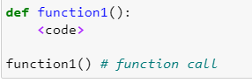

## **Question 3:** What statement creates a function.

**Answer**:

* def is the keyword to define function.
* **def** <function name>:

<function code>

## **Question 4:** What is the difference between a function and a function call?

**Answer**:

* “**Function**” is a piece of code to do some tasks.
* Whereas “**Function call**” is to invoke/call the Function to execute the function code.

## **Question 5:** How many global scopes are there in a Python program? How many local scopes

**Answer**:

* There is only one global scope for the program until its name or value changed.
* There can be more than one local scope dependents on the program. The variable defines within function/ class will be act as local variable.

## **Question 6:** What happens to variables in a local scope when the function call returns

**Answer**:

* When a function returns, the local scope is destroyed, and all the variables in it are forgotten.

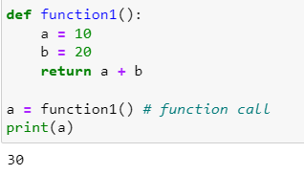

## **Question 7:** What is the concept of a return value? Is it possible to have a return value in an expression

**Answer**:

* A return value is the value that a function call evaluates to. Like any value, a return value can be used as part of an expression.

## **Question 8:** If a function does not have a return statement, what is the return value of a call to that function

**Answer**:

* The answer is None.

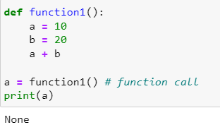

## **Question 9:** How do you make a function variable refer to the global variable

**Answer**:

* Using ‘global’ keyword, we can make function variable as global variable.

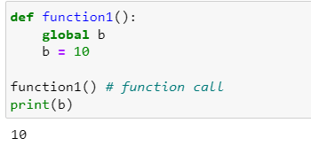

**Question 10:** What is the data type of None

**Answer**:

* None is the datatype of the class NoneType and None is a keyword and object of the NoneType class.

**Question 11: What does the sentence import areallyourpetsnamederic do**

**Answer**:

* If such module is already created by user, then it is possible. If not, it will throw error as such module is not found.

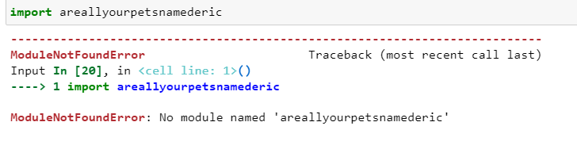

**Question 12:** If you had a bacon() feature in a spam module, what would you call it after importing spam

**Answer**:

* This function can be called with spam.bacon()

**Question 13:** What can you do to save a programme from crashing if it encounters an error?

**Answer**:

* We can use try..except. Place block of code that assumes to get error and place block of code in except clause to handle error.

**Question 14:** What is the purpose of the try clause? What is the purpose of the except clause?

**Answer**:

* Try clause is used to place code lines which have chance to cause errors. Except clause is used to place code lines if any error occurs in Try clause.